**Sustainable Impact of the Ardnacrusha Hydroelectric for the Shannon Region**

**🚀 Challenge Theme**

**“Balancing energy, environment & innovation in the Shannon basin”**

**📖 Introduction / Context**

The Ardnacrusha Hydroelectric Station has long been a pillar of Ireland’s renewable energy system. But as the Shannon region evolves as a hub for research, advanced manufacturing, and sustainability, we must rethink how Ardnacrusha contributes not just to energy supply, but also to ecological health, regional innovation, and community resilience.

But this raises key questions:

* How can Ardnacrusha continue to power industry and homes sustainably?
* How can we protect biodiversity, particularly salmon migration?
* How can infrastructure upgrades, digital tools, and space technology make it smarter, cleaner, and more efficient?

Figure 1 Ardnacrusha Hydroelectric

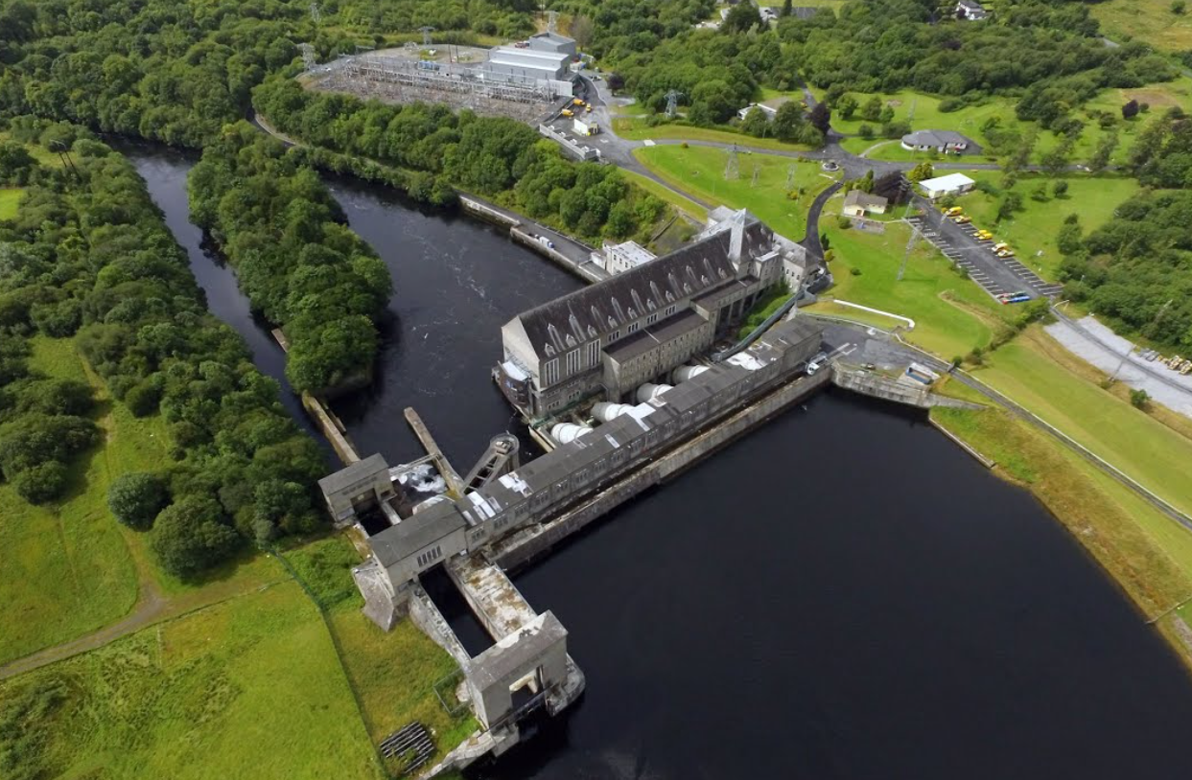

Figure 2 Ardnacrusha Hydroelectric

Figure 3 Ardnacrusha Hydroelectric

Figure 4 Ardnacrusha Location

**❓ Challenge Statement**

How can we reimagine Ardnacrusha’s sustainable impact so that it:

* Delivers reliable, clean energy to industry while preserving the Shannon ecosystem,
* Modernises infrastructure for efficiency and ecological compatibility,
* Supports regional innovation, research, and manufacturing,
* Applies space-enabled tools (satellite, IoT, digital twins),
* Yields quantifiable social, economic, and environmental benefits for the Shannon region?

**🎯 Missions (Team Tasks)**

| **Mission** | **Focus** |
| --- | --- |
| **1. Optimize Energy & Infrastructure** | Propose upgrades to turbines, control systems, or hydraulic flow that boost output or efficiency by 3–10%. |
| **2. Ecosystem Protection & Restoration** | Design fish passage systems, flow management, or habitat redesigns to raise salmon survival rates. |
| **3. Monitoring via Space & Sensors** | Use satellite imagery, drones, sensor networks, or digital twins to monitor river health, infrastructure stress, or fish migration. |
| **4. Regional Innovation Ecosystem** | Define pathways to attract startups, research labs, or manufacturing powered by Ardnacrusha’s clean energy. |
| **5. Impact Quantification & Transferability** | Model energy gains, biodiversity benefits, job creation, CO₂ reductions — and propose how it could apply to other rivers worldwide. |

**📊 Challenge Metrics (Inspiration)**

* +5% efficiency = enough extra electricity for ~4,400 households
* Salmon survival raised from < 50% → 70–80%
* Industrial CO₂ reduction of through green energy supply
* Monitoring costs reduced using satellites & IoT
* New green jobs, startups, and education opportunities in Shannon

**🤝 Resources & Collaborators**

* **Data:** Hydrology of the Shannon, salmon migration

https://esb.ie/what-we-do/generation-and-trading/hydrometric-information

* **Tools:** Satellite data, IoT kits, drones
* **Partners:** ESB, Siemens, Irish Waterways, Universities, Research Institutes
* **Frameworks:** EU Green Deal, Irish renewable & biodiversity policies

Figure 5 Average Daily Ardnacrusha Flow Data

**🏆 Evaluation Criteria**

1. Feasibility & Clarity
2. Relevance to energy–environment balance
3. Innovation & Creativity
4. Quantifiable Impact
5. Transferability to other hydro contexts
6. Effective use of tech & partnerships

**🌍 Why This Matters**

Solutions from this challenge could:

* Provide **energy resilience** for local homes & industries
* Protect and restore **river ecosystems & salmon populations**
* Spur **new green industries, startups, and jobs** in Shannon
* Position Shannon as a **sustainability innovation hub**
* Create **models for sustainable hydropower** applicable worldwide